Economic Inequality Capstone Project – Nisha Kudva
Project Questions & Responses
Adult Census Income Dataset - US Census Bureau, 1994
Analysis of 26,904 cleaned records (82.6% of the original 32,561)
This report answers the core research question defined during class, plus four additional questions relevant to the investigation. Every statistic is computed from the cleaned dataset and can be reproduced from the project code.

Primary Research Question
Q. How does the proportion of individuals earning more than $50K vary across different workclass categories, and what underlying factors might explain these differences?

Response
The likelihood of earning more than $50K varies dramatically by workclass, a roughly 2.5-fold difference between the highest and lowest categories (ignoring the tiny Without-pay group). Business owners who have incorporated their firms are far more likely to be high earners than employees of any kind, and within government, federal workers substantially out-earn state and local workers.
Workclass | % earning >$50K | People (n)
Self-emp-inc (incorporated) | 55.6% | 1,049
Federal-gov | 38.3% | 929
Local-gov | 29.4% | 2,014
Self-emp-not-inc | 28.7% | 2,431
State-gov | 27.1% | 1,253
Private | 22.4% | 19,214
Without-pay | 0.0% | 14
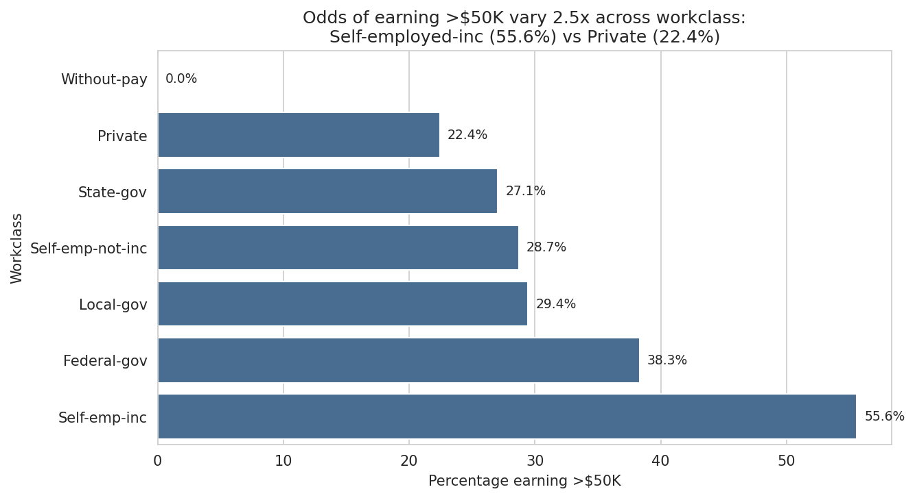
Figure A. Proportion earning >$50K by workclass.

Does the gap survive when we compare people with the same education?
Yes. This is the key test, if the workclass gap were purely a by-product of some sectors employing more graduates, it would disappear once we hold education constant. It does not. Comparing only people with a Bachelor's degree:
Workclass (Bachelor's holders only) | % earning >$50K
Self-emp-inc | 61.9%
Federal-gov | 45.6%
Private | 42.0%
Self-emp-not-inc | 41.1%
Local-gov | 34.8%
State-gov | 32.7%
Among identically-credentialed Bachelor's holders, an incorporated self-employed person is about 20 percentage points more likely to earn >$50K than a private-sector employee (61.9% vs 42.0%). The same pattern holds among high-school graduates, where Self-emp-inc reaches 42.7% versus just 15.2% for Private. Workclass therefore adds inequality on top of what education explains, satisfying our pre-defined meaningful-finding threshold of a ≥10-point gap that persists within education levels.
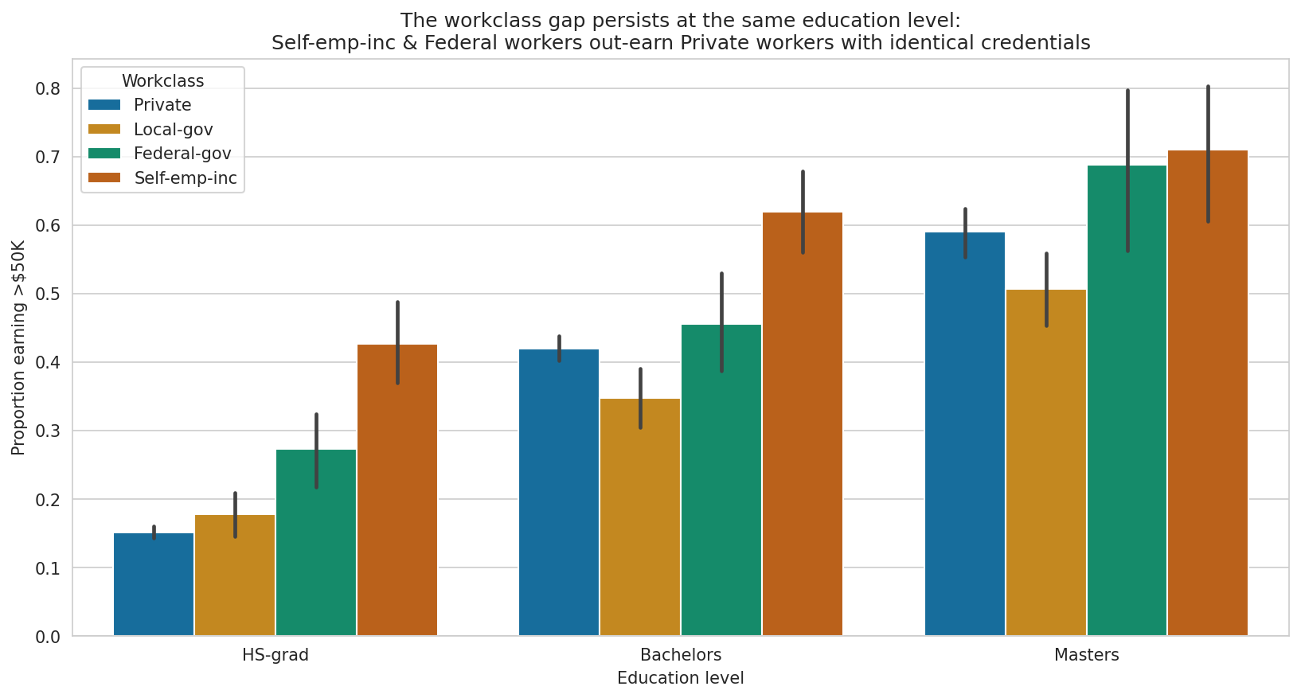
Figure B. The workclass gap persists within each education level.

What underlying factors might explain these differences?
The dataset lets us point to several plausible contributing factors, though it cannot prove causation:
- Business ownership & capital income. Incorporated self-employment (top of the list) reflects owners who take profit and capital gains, not just wages, a fundamentally different income structure than an hourly or salaried employee.
- Hours worked. The two self-employed groups work the longest weeks on average (48.8 and 44.4 hours) versus ~40 for private-sector workers, so part of the gap is simply more hours.
- Job security & pay scales in federal work. Federal roles (38.3%) out-earn state (27.1%) and local (29.4%) government, consistent with federal General Schedule pay scales and a higher concentration of professional/skilled positions.
- Age & career stage. Self-employed and federal workers are older on average (46, 45, 43 years) than private-sector workers (37), and Figure 3 in the main report shows income rises with career stage.
- Sector composition. The Private category is huge and heterogeneous (19,214 people, 71% of the sample) it blends high-paying finance and tech roles with low-paying service jobs, which pulls its average down.

Why it matters
If two equally-educated people face very different odds of a high income purely because of the type of employer they work for, that is a structural feature of the labour market, not a difference in personal effort or qualifications. It suggests that policy aimed only at raising education will leave gaps untouched; pathways into federal employment and support for business ownership are levers that education policy alone does not pull.

Additional Questions
Q. Does higher education close the earnings gap between men and women?

Response
No. The gender gap persists at every education level and is actually widest among the most educated. Overall, 32.3% of men earn >$50K versus only 12.1% of women. Holding education constant does not remove it: among Bachelor's-degree holders, 50.4% of men earn >$50K compared with 22.6% of women, a 28-point gap at an identical credential. This was the most surprising finding of the investigation, because the intuitive expectation is that a degree levels the playing field. It does not: education raises everyone's odds, but the male–female gap remains, pointing to factors the dataset does not capture directly; occupation mix, industry, hours, and career interruptions.
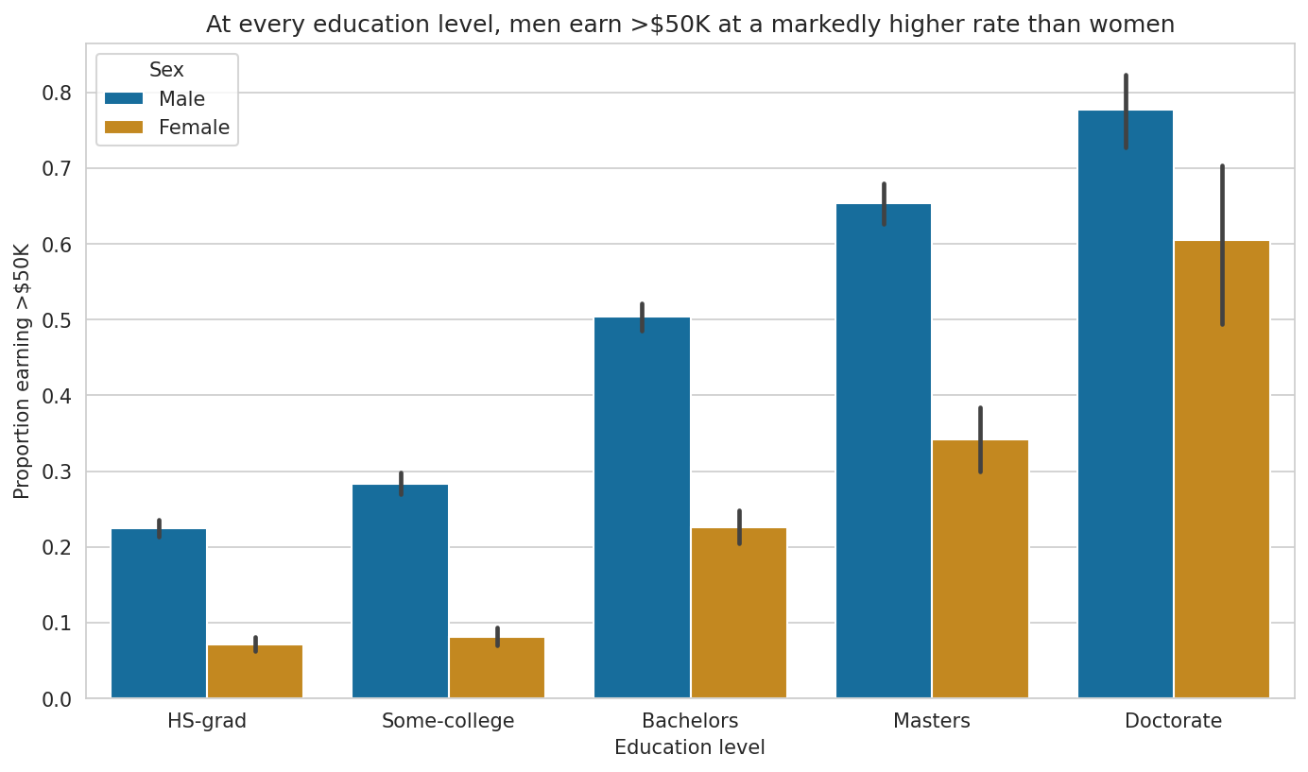
Figure C. Proportion earning >$50K by education, split by sex.
Q. Which machine-learning model predicts income best, and can we trust its accuracy?

Response
Gradient Boosting performed best (accuracy 0.841, F1 0.623 on the >$50K class), narrowly ahead of AdaBoost and the neural network. But accuracy alone is misleading here because the classes are imbalanced: a most-frequent baseline that never predicts >$50K still scores 74.4% accuracy while identifying zero high earners. That is why the table below ranks by F1, which balances precision and recall, rather than by accuracy.
Model | Accuracy | Precision | Recall | F1
Gradient Boosting | 0.8406 | 0.7884 | 0.5145 | 0.6227
AdaBoost | 0.8275 | 0.7240 | 0.5262 | 0.6094
Neural Network (MLP) | 0.8288 | 0.7486 | 0.4978 | 0.5980
Logistic Regression | 0.8212 | 0.7379 | 0.4666 | 0.5717
Baseline (most-frequent) | 0.7443 | 0.0000 | 0.0000 | 0.0000
For a use like loan-eligibility screening, recall matters more than raw accuracy: a false negative (missing a genuine high earner) wrongly denies someone an opportunity. Even the best model catches only ~51% of true high earners, so it is not suitable for high-stakes decisions.
Q. Is the best model equally accurate for men and women?

Response
No. A fairness audit of the Gradient Boosting model by sex shows the model correctly identifies only 35.1% of women who actually earn >$50K, versus 54.6% of men. Paradoxically its accuracy looks higher for women (91.8% vs 80.2%), but that is an artefact of imbalance: because fewer women are high earners, always guessing '≤50K' is a safe bet that scores well on accuracy while failing the women who do earn more.
Group | n | Accuracy | Recall (>$50K)
Female | 1,794 | 0.918 | 0.351
Male | 3,587 | 0.802 | 0.546
Consequence: if such a model pre-approved loans or set insurance rates, high-earning women would be systematically under-recognised, the model would reproduce, and potentially amplify, the very inequality the data reveals. A model that looks fair on averaged accuracy can still be unfair per-group.
Q. What can this 1994 dataset NOT tell us, and who is missing from it?

Response
The data is a 1994 snapshot, so it cannot describe today's wage structure: $50K in 1994 is not $50K today, and whole sectors (the modern tech and gig economy, remote work) did not exist in their current form. It also under-represents people who were not counted in the Census or not in formal employment, undocumented workers, people in informal cash work, and some unemployed individuals. Additionally, our own cleaning choice to drop rows with missing workclass/occupation may further remove people at the margins of the labour force. Every conclusion in this report therefore describes the 1994 US workforce and should motivate current measurement rather than substitute for it.

Summary of Findings
- Workclass matters independently of education: a 2.5x spread in high-earning rates that persists within education levels (Self-emp-inc 55.6% vs Private 22.4%).
- Education helps but does not equalise: men out-earn women at every level; the gap is widest for degree holders (50.4% vs 22.6% at Bachelor's).
- Best model is accurate but not fair: Gradient Boosting reaches 84% accuracy yet finds high-earning women at a far lower rate than men (35% vs 55% recall).
- Historical scope: findings apply to the 1994 US workforce and should guide present-day measurement, not present-day decisions about individuals.

